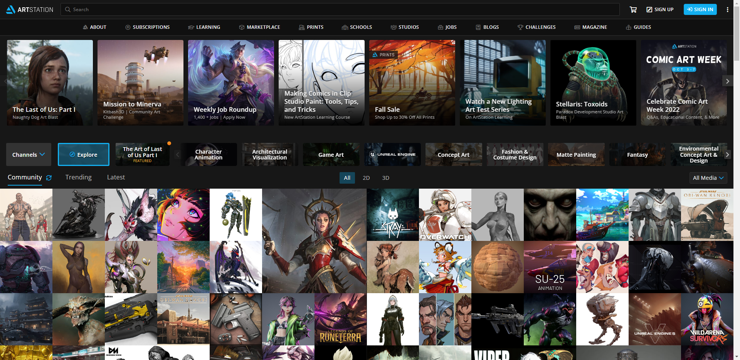

[ArtStation](https://www.artstation.com/?sort_by=community)

<section>

<nav>

<nav>

<section>

<article>

<article>

<article>

<article>

<article>

<main>

<header>

<nav>

<logo>